**DHCP CONFIGURATION**

DHCP configuration is a technology used to automatically assign IP addresses to devices on a network. DHCP can be applied on a router or generic server. The steps below will guide you on how to configure a **DHCP server**both on a router and on a generic server in Cisco Packet Tracer. In both cases, configuration is simple as long as you have a basic knowledge of IP addressing.

**Configuring DHCP server on a Router.**

1. Build the network topology:

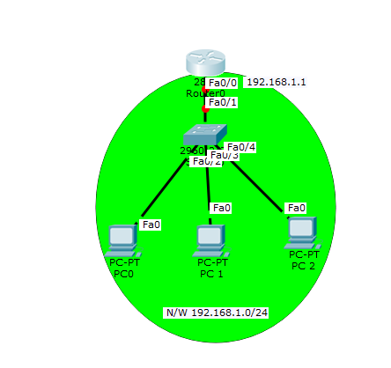

2. On the router, configure *interface fa0/0* to act as the default gateway for our LAN.

**Router>enable**

**Router#config terminal**

**Router(config)#int fa0/0**

**Router(config-if)#ip add 192.168.1.1 255.255.255.0**

**Router(config-if)#no shutdown**

**Router(config-if)#exit**

3. Configure DHCP server on the Router. In the server we will define a **DHCP pool** of IP addresses to be assigned to hosts, a **Default gateway** for the LAN and a **DNS Server**.

Router(config)#

**Router(config)#ip dhcp pool MY_LAN**

**Router(dhcp-config)#network 192.168.1.0 255.255.255.0**

**Router(dhcp-config)#default-router 192.168.1.1**

**Router(dhcp-config)#dns-server 192.168.1.10**

We can add ip dhcp excluded-address command to our configuration so as to configure the router to exclude addresses 192.168.1.1 through 192.168.1.10 when assigning addresses to clients. The **ip dhcp excluded-address** command may be used to reserve addresses that are statically assigned to key hosts.

So add the above command under the **global configuration mode.**

Router(config)#ip dhcp excluded-address 192.168.1.1 192.168.1.10

4. Now go to every PC and on their **IP configuration** tabs, enable **DHCP**. Every PC should be able to obtain an IP address, default gateway and DNS server, as defined in step 2.

For example, to enable DHCP on PC1:

Click **PC1->Desktop->IP configuration.**Then enable DHCP:

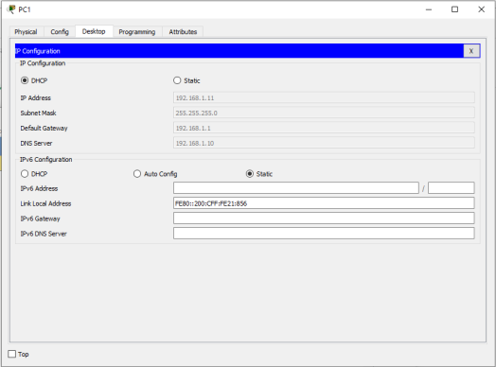

Do this for the other PCs.

You can test the configuration by pinging PC2 from PC1. Ping should succeed.

It’s that simple!

Now let’s do the same thing using a Generic server in place of a router:

**Configuring DHCP service  on a generic server in Packet Tracer.**

1. Build  the network topology in packet tracer

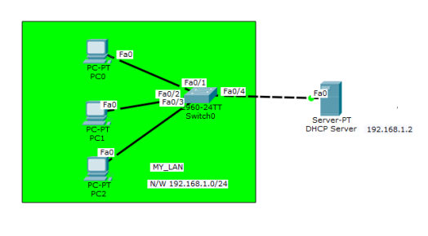

2. Configure static IP address on the server (192.168.1.2/24).

3. Now configure DHCP service on the generic server.

To do this, click on the server, then click on **Services tab**. You will pick **DHCP** on the menu. Then proceed to define the DHCP network parameters as follows:

**Pool name**: MY_LAN

**Default Gateway:**192.168.1.1

**DNS Server:**192.168.1.2

**Start IP Address:**192.168.1.0

**Subnet Mask:** 255.255.255.0

**Maximum Number of users:**256

Click on **add** then **Save.**The DHCP entry is included in the list.

Here are the configurations on the server:

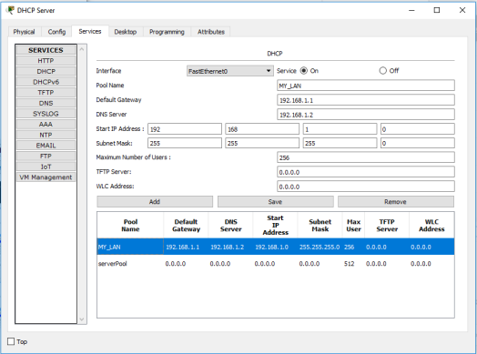

Once you’ve configured everything, turn **ON** the DHCP service.

4. Finally, enable DHCP configuration on each PC. The three PCs should get automatically configured.

As an example, here is the DHCP configuration on PC1:

